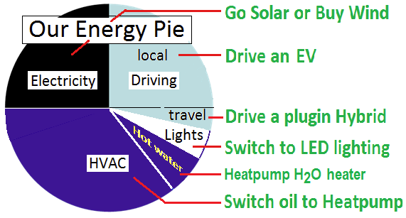
Energy Choices [Bob Bruninga – bruninga@usna.edu]
Meeting for Learning AFM 26 Mar 2017 (rev b)
Download PPT: http://aprs.org/energy-choices-n.ppt

We face on average a major energy decision about every 2 years. Choose Clean Energy. It is actually cheaper in the long run.
See summary web page: http://aprs.org/Energy-Choices.html
Everyone can choose Wind or renewables electricity from their utility. Everyone can switch to LED lighting! And save 80% on energy.
Everyone can learn to drive as if they have no brakes (brakes waste 50% of a gas cars energy). Learn about EV’s - our future is here! See http://aprs.org/EV-misinformation.html
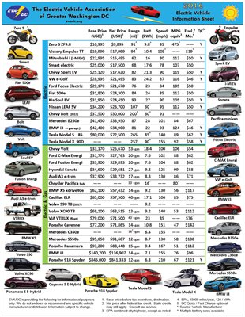
Cars are at least a third of our fossil burning pie. But 90% of our driving is local. EV’s are now better, faster, cleaner and cheaper to buy, to operate and to maintain than gas cars. There are now 28 EV’s of the 40 on the market that cost less than the average $35k gas car, plus now 8 years of used EVs available starting at $6k and up.
If you only have one car, but have a place to plugin every night, get a Plugin-Hybrid. A plugin-hybrid can drive locally on Electric but can drive hundreds of miles on gas when needed. Download the EV car list from http://evadc.org

If you can plug into an outlet at work you can gain 40 electric miles a day there.
If you have access to two cars, at least one can be pure electric for local travel and commuting, the other can be a plugin-hybrid or SUV or whatever you need for family travel.
If you own your home, consider a heatpump water heater next time your old electric one dies. It will save 60% on energy and pay for itself in only a few years.
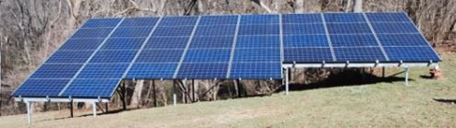
If you are burning heating oil, please upgrade to a heatpump at the next failure and save 60% on energy costs. Natural gas is cleaner, but still 50% carbon. A heatpump runs from your electric solar or wind from the utility and can be 100% renewable.
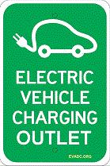
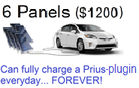
If you have a sunny roof or yard, Solar will save you tens of thousands of dollars over the next 20 years of clean renewable energy. If you have too much shade, do you really need it? Solar panels are as good as 200 trees as far as carbon reduction, so if one is in the way, cut it down.
Everywhere you see an outdoor outlet, ask about putting up a sign to show how ubiquitous EV charging can be anywhere, everywhere if needed. It will be rarely used, but everyone will see it and learn. Cost is 20 cents an hour to charge. See our successes: http://aprs.org/EV-charging-signs.html
See our own AFM Energy page: http://aprs.org/AFM-environment.html

