Solar - Annapolis Friends Meeting http://aprs.org/AFM-environment.html
We decided to go solar back in 2011 or so, but it took a while to come up with a design that was good for us and Solar City. We wanted a ground mount due to shade on the roof and also to avoid the considerations of whether our 20 year old roof needed replacing first (which would have cost more than the Solar in the first place). The array was installed in February 2014. We paid about $1k more to have it stepped level horizontally instead of following our sloping terrain.
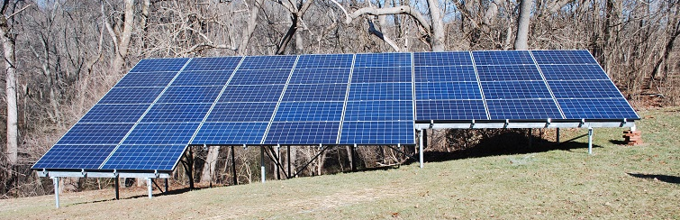
Solar City Fully Prepaid Lease: Our array was a prepaid 20 year lease for a onetime payment of $21,000. This was near the cost for a homeowner after the 30% tax credits and state and local grants at the time. But as a church, none of these credits would apply and it would have cost us $53,000 to purchase. With the lease, Solar City got all the credits and grants and then passed it along to us in a low onetime payment. Now, Solar City only does churches on a case basis. The electric meter has to be residential and they will not do month-to-month lease due to poor credit ratings for churches. Now 6 years later, our array would cost a homeowner only about $30,000.
Amortized over 20 years, our cost is about 6 cents/kWh compared to nearly 14 cents from BGE.
Ground Mount: The ground mount avoids any roof issues and allowed an excellent South facing array. (South is not that important for Grid-Tie systems since anything from SE to SW will still do 95% as well. Even East or West can do 85% and often have double the roof area.
Capacity: The array is 9 kW which met 100% of our annual electric needs saving us about $1500 per year… That is, until we switched from Propane to electric heatpump.
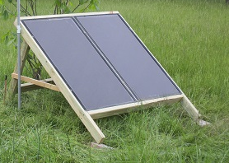
Heatpump vs Propane: Next we swapped our fossil fueled propane heating system for a heatpump and saw our propane cost go down from $4500, while only adding about $1500 back to our electric bill. This $1500 is coming from wind power we subscribe to from the utility. A second solar array is in the works to reduce that to zero. And we are back to carbon free living.
Camp Solar: We also have plenty of donated smaller solar panels to give to youth groups or camps or homeless to educate and bring solar to the wilderness. See http://aprs.org/camp-solar.html
Electric Vehicle Support: We also added standard outdoor outlets on our lamp-posts to support EV’s. In our small meeting, we now have at least 6 EVs and our meeting house is popular as a carbon free meeting location. See our pages: http://aprs.org/AFM-environment.html

