Position Statement
Electric Vehicle Public Charging and Charging-at-Work
The recent visibility of Electric Vehicles (EVs) as a key to our future energy and environmental policy is confusing to the public who are subconsciously biased towards a century of legacy thinking based on the gas tank and public gas station model. We are seeing a tendency for both the public and professionals to lump EVs into a battery box model and to then compound all possible issues with all possible ramifications when making decisions about the future of the EV infrastructure by this unconscious comparison to the gas car experience. This one-size-fits-all approach is detrimental to the acceptance of EV’s for applications where they are best.
An EV is generally not a one-for-one replacement for a gas car. One initial optimum application is for the daily commuter with a reasonable distance to work and a place to plug it in. Every EV comes with a standard 115v charging cord for home charging, but almost all public discussion and infrastructure investment is focused not on the convenience of routine 8 hour charging on 115v from standard outlets at home and at work (L1), but on fast public charging (L2). This off-target focus is based on the legacy drive-to-empty and gas-station fill-to-full gas tank model, but is inappropriate for the EV commuter model. The EV model is more of a commuting appliance, to be plugged in at home and at work, than the legacy go-fill-up-at-a-public-charging-station experience of the American public. We should:
- Not oversell EVs as gas car replacements across the board and where inappropriate
- Recognize that charge-at-home and charge-at-work covers 90% of all USA commutes
- Recognize 300 million commuters (67%) have homes with easy access to outlets
- Encourage Employer charging-at-work to double the EV commuter’s range
- Avoid public EV charging statements that do not differentiate L2 from L1 charging
- Encourage informal monthly payin-to-plugin programs for the ~ $1/day cost of electricity
- Educate the public of the advantages of L1 charging at home and at work
- Encourage L1 charging to avoid peak loads and neighborhood utility clustering problems
- Encourage L1 charging from standard outlets to avoid expensive electrical work
- Encourage L1 charging cords at low cost for sale to the consumer
- Encourage L2 fast chargers at short-duration spaces for easy access to many cars a day
- Discourage L2 chargers in long-term/daily lots where 1-hr charged cars block usage
- Recognize that most EV charging issues apply mostly to L2 and not to L1 charging
- Recognize that L1 utility load leveling can be easily accomplished in bulk employer lots
- Educate the public how L1 charging can be better for long battery life than fast charging
- Avoid magnifying L2 issues/concerns/problems when L1 solutions exist
- Continue full support for fast L2 and L3 charging, but not to the extent of masking L1
- The 200 M EV goal in 20 years won’t be met with the single minded public L2 approach
Conclusion: The EV is a very significant solution to our future energy, environmental, and national security problems. We must not let misinformation, and public confusion based on a century of quick-fill-up-gas-tank legacy thinking undermine or slow this radical new technology.
Draft by: Bob Bruninga, PE bruninga@usna.edu, 410-293-6417
Supporting Data: Data from GM below shows that USA vehicles spend more than 90% of their existence parked at home or at work. Charge infrastructure planning for EV’s should fully consider this demographic. That is more than 21 hours a day available for charging while parked.
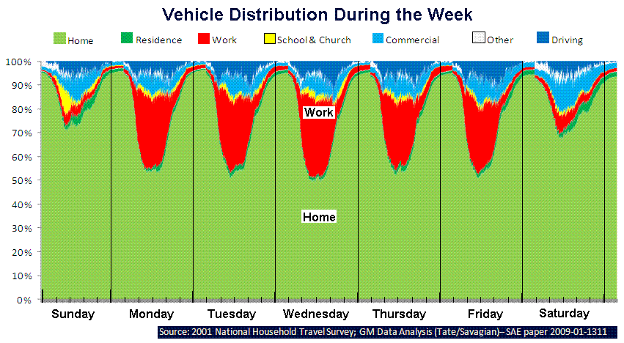

A Battery is not a Gas Tank: Gas tanks are filled-to-full and run-to-empty and then filled-to-full at public gas stations. This is not the EV model. EV’s are charged at home and charged at work at lowest cost and where convenient and, in the long term, will only be charged at expensive public charging in extremis or for peace-of-mind.
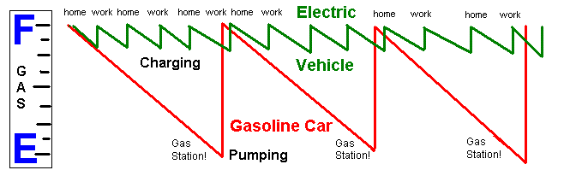
EV Charging: All EV’s come with 115v (L1) charge cords. The GM model for the Volt shown below, assumes the majority of all charging will be at home, next will be routine charging at work and only the tip of the charging pyramid will be at work as shown in the following GM graphic (with notes added). Notice how looking for public EV charging (at 3 times higher rates than at home) is like looking for $10 gas stations; a tactic usually avoided by most drivers.
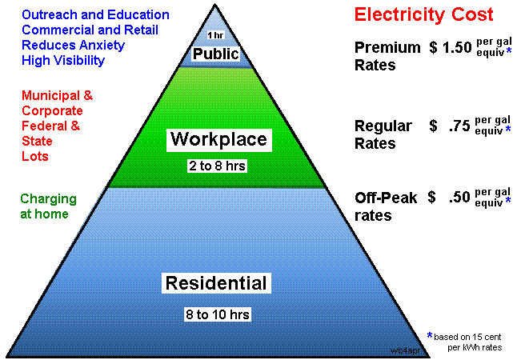

Commuter Statistics: DOT Bureau of Transportation statistics (purple below) show 90% of all USA commutes are 32 miles or less. The green shows the low cost to charge at 15 cents/kWh and the red prices below show the cost per month for charging-at-work for those distances.
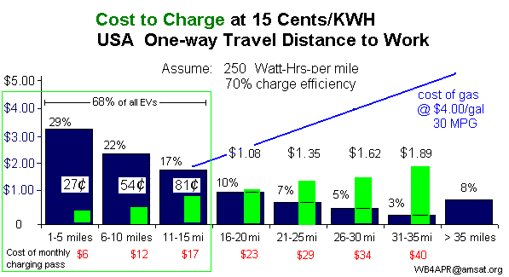
Level-2 Charging: The same data can be used to show (in red below) how placement of L2 chargers at work or other 8 hour daily parking lots wastes at least 83% of charging capacity because 70% of all commuters are fully charged in an hour or less, and 90% in under 2 hours. The rest of the day, these chargers are blocked from use by any other cars.
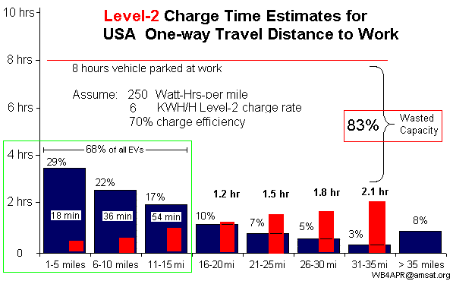

L1 Charging: In contrast, the same data can show how 90% of all commuters can fully charge in 8 hours or less on simple 115v outlet power (L1). And even then, the L1 charge cords are only using 37% of their overall capacity.
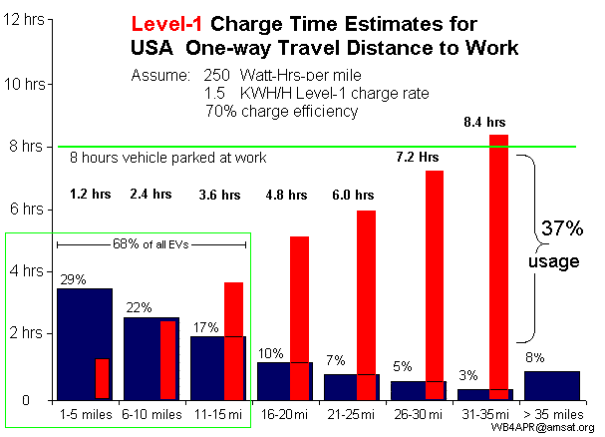
The Wrong Emphasis on At-Home and At-Work Charging: The public focus is being misdirected by the common metric of hours-to-full-charge, instead of miles-per-charge for 8 hour at-home and at-work charging. The graphics above and below show how the size of the battery is not the primary metric for the convenience of L1 charging, but it is the length of the commute:
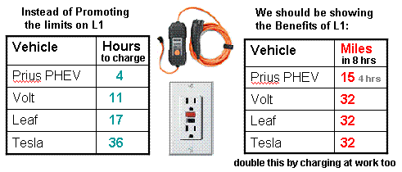

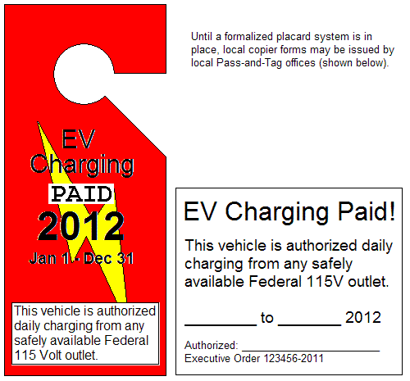
Payin-to-Plugin: Due to the public focus on the high costs of L2 fast charging there is an obsessive attention to pricing and usage metering. But this primarily comes from the gas-station model where a fill-up can cost from $50 to $100. It does not apply to the daily EV charge that generally consumes a $1 a day or less to full charge.
The simpler approach to the EV commuter car (appliance) charging is to simply pay the employer in advance for the nominal rate of electricity used for the daily commute to work. A simple monthly charging pass as shown here can easily be implemented by most employers. The cost of this placard would be from $6 to $24 per month for 80% of all commuters.
These payin-to-plugin passes can be managed by the employer as easily as the process they currently use to manage handicapped parking spaces and illegal parking now.

Charging-at-Work has great potential for the Utilities: Although charging-at-work is desired by the EV owner, it would appear to be against the desires of the utilities that want to avoid additional on-peak daytime loads. But concentrating charging-at-work at major employers gives the opportunity for cost-effective real-time bulk control of instantaneous charging by the utility (or employer) as a means for load leveling. In the chart below, the routine minute-by-minute regulation of power can be used to charge as many as 40,000 EVs at no significant additional cost to the utilities.
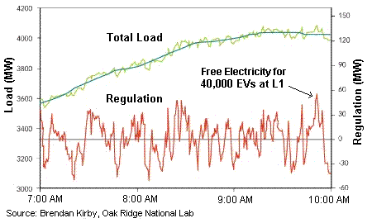

EV Charging Problems and Issues: Generally, most public documentation and discourse on the EV infrastructure issues do not take the effort to distinguish between those issues that apply to L2 charging as opposed to any issues that might apply to L1. In fact, all of the following commonly addressed EV infrastructure Charging issues apply only to L2 and generally do not apply to early adopters using L1 charging at home or at work:

- Charging Equipment Cost
- Installation Labor Cost
- New high current wiring Costs
- Larger circuit breaker box often needed
- Metering (Payment System) Costs
- Neighborhood Clustering
- Neighborhood Utility Transformer upgrade
- Grid Loading
- Peak Demands at Peak load
- Charging Speed
- High rates reduce battery life

What’s good for the Battery: Finally, what is good for the EV battery is usually not fast charging. Of the eight recommendations for best EV battery life, five of them are benefited by avoiding L2 charging and using L1 charging instead:
#1. Avoid full charging when you can.
#2. Avoid deep discharging your battery pack.
#4. Minimize the time spent at a high state of charge.
#6. … plug in whenever you can.
#8. To maximize battery life, minimize use of DC quick charging.

Draft by: Bob Bruninga, PE bruninga@usna.edu, 410-293-6417

