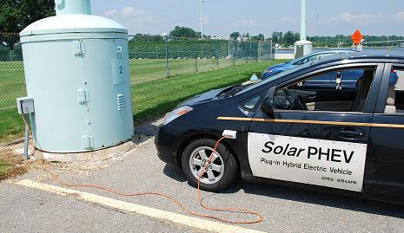
CEO Executive Order:
Authorizing pre-pay for EV Plug-in

http://aprs.org/EXorder-EVs.html

Bob Bruninga, WB4APR
Wb4apr@amsat.org

Let us PAY-in to PLUG-in!:

We have electric cars.
We have outlets at work.
We work on Company grounds and park in Company parking lots
We need authority to plug in and a Method to pay! This is a NO COST - SELF HELP project!

We are asking for an EXECUTIVE ORDER from the CEO authorizing the parking adminstrator offices to sell monthly pre-paid EV CHARGING PLACARDS (below) to employees at a cost equal to the cost of electricity (about $10 per month. Or $100 per year) for daily charging on existing 115V outlets.

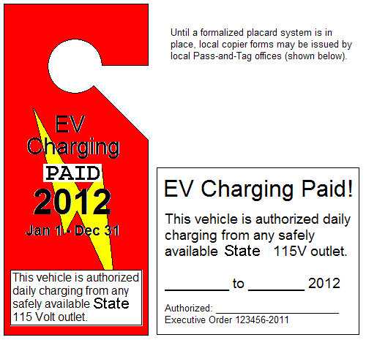
This placard (if PAID) allows the EV to plug into any convenient 115 VAC outlet on company property that is -safely- located within a few feet of an existing -valid- parking spot. No special chargers or installation is required. Enough existing exterior 115 volt standard outlets can usually be found to equal the number of EV's that work there! .

This NO COST executive order will accomplish far more than the $50 Million government rebate going for the installation of overly expensive EV quick chargers which are not actually needed in many cases (for overnight charging). Especially since the charging requirement will be cut in half if charging is also allowed at work. Expensive Quick chargers are not needed at work, where the cars just sit for 8 hours!

The cost for 20 workdays a month of 8 hours of electricity from any standard 115 volt 15 amp circuit is about 50 cents a day. That is about $10 a month at 10 cent electric rates. Company electricity costs less than that, so $10/month should more than cover the electricity used and cost of the placards.

Power drawn is Self-Limiting. This arrangement cannot be abused since one simply cannot draw any more than about 50 cents a day from a 115 volt 15 amp outlet during an 8 hour day. Drawing more amps, trips the breaker. Staying plugged in longer runs up against the problem of a full battery! Once the car's battery is fully charged (which for most EV's is 8 hours) then no more power can be drawn from the outlet!

Range Anxiety and Public Charging Infrastructure: There is just too much hype and media hand wringing over EV range. This is silly. People who have range anxiety or live too far from work for a plug-in simply should not buy an EV at this time. Still hundreds of millions of drivers can use an EV without any concern over charging infrastructure (if they can also charge at work to double their range)!... Over 60% of ALL Americans live in single family detached homes. This means over 250 MILLION car owners already have an EV charging point at home (any 115v outlet) and we are only looking for 1 million EV's by 2015. We can double the number of EV wanna-bees simply by making it easy to charge at work. And we don't need a $3000 quick charger to do it!

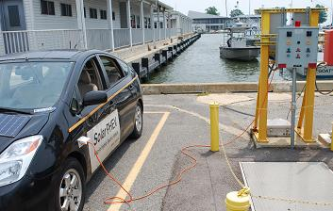
One Million EV's is not a small number! There are over 400 different models of gas cars sold by 45 manufacturers to meet the spread of public demand for vehicles that match their needs. Even the #1 selling gasoline vehicle in America only sells to 4% of Americans! If only 1% of drivers bought an EV, that would be 3.5 million EV's! Since 67% of ALL drivers already have a charger port at home (115 VAC outlet), Allowing outlets at work could INSTANTLY DOUBLE THE RANGE of every EV at NO COST to taxpayers.

Existing Outlets are Available: The number of existing available 115v outlets near parking places may be small, but so also are the number of EVs now. One Million EV's by 2015 breaks down to about 11 cars at the Naval Academy, yet I counted over two dozen available outlets or power boxes adjacent to parking places (where a $5 outlet could be added) as shown here.

Enabling this Pay-in to Plug-in process to use those existing outlets will jumpstart the acceptance of EV’s. No one is getting free electricity here, owners pay for the placard, and that goes into the company coffers to more than offset the costs of the electricity. The only concern might be unsafe practice with the cords as shown below.

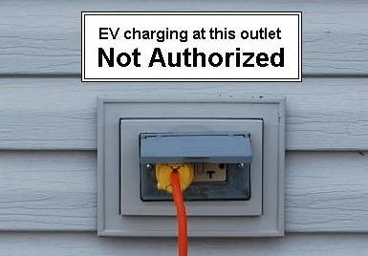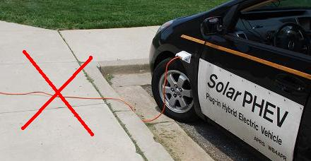

Safety and FOUO: Any concerns over unsafe routing of charging cords can be easily met by marking any such
tempting outlets in unsafe areas as Not Authorized as shown above. Similar signs on official company charging stations not authorized for charging of personal vehicles could also be marked For Company Use Only.

Double the EV Range: This is truly a no-cost idea that can jump-start the electrification of transportation and its environmental and economic benefits by doubling the range of EV's for employees. It can also demonstrate to other large government and commercial facilities the benefits of such an approach on their campuses.

Although the GAO has determined that appropriated funds cannot be used by the Federal Government for either the installation of expensive quick-charging stations or to establish a reimbursement procedure for their use by private owners, this ruling applies only to the purchase and installation of new government chargers! It does not apply to existing 115v outlets that already exist! Nor to the company. Please, let’s use common sense!

A Forward Thinking Bureaucrat in the Company could make this happen overnight!

Bob Bruninga wb4apr@amsat.org 410-293-6417
IEEE National Committee on Transportation and Aerospace
EV Association of DC

