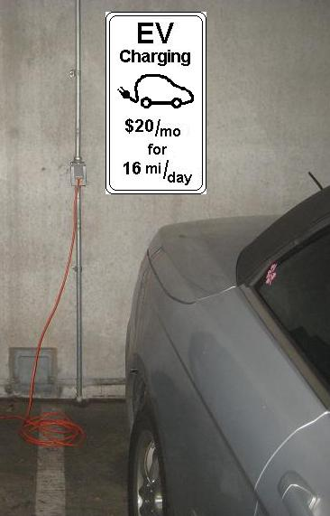
Annapolis Town Center Mall 8 Feb 2012
Address line 1
Annapolis, MD 21401

Dear Town Center Building Management,
When I parked in one of your garages, I noticed several existing standard 115v outlets which are well suited for charging an Electric Vehicle. All EV’s come with their own charging cord that can be plugged into any 115v outlet. You could enable these outlets for EV charging for no cost.
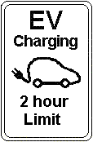
All you need to do is simply put up a sign as shown in the photo (monthly pass for employees), or for visitors to the Town Center, just let it be an incentive to attract customers. The cost of electricity for a 2 hour charge is about 25 cents. The good will to customers is worth far more than the effort to collect the 25 cents.
The 115v outlets are not fast charging, but attract visitors, and they put your site on the EV charging map. In 2 hours on 115v, about 10 miles range is added. This is enough to fully top-off your customers from Anne Arundel County or Kent Island.
Your EV employees do not need a fast L2 charger either because their cars will sit for 8 hours and during 8 hours, the vehicle picks up about 32 miles range from a standard outlet. This is enough for your daily employees who live as far away as Baltimore, Washington, Easton or Chestertown.
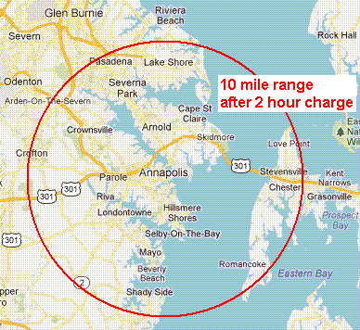
Please do not let me dissuade you from the purchase of a fast 240V charger if that is your intention. But if you are putting off the addition of fast L2 chargers, at least in the meantime, enable your employees and customers to simply plug into your existing 115v outlets in your garage.
Just put up the signs (only one sign per circuit breaker). If I can assist in any way, please let me know. I am not selling anything. I am just a 20 year EV owner who is frustrated by not being able to plug into existing outlets due to lack of public understanding of the simplicity of 115v EV charging. For background, see http://aprs.org/payin-to-plugin.html.

Your name and email address here
Your association here, etc

