US Naval Academy Small Satellite Program

ANDE MAA Power System Clarifications:

(rev4) 20 July 2006
Bob Bruninga, PE

This report addresses the details of differences in the as-built configuration of the ANDE MAA battery power system and the slide presented at the Phase 3 Safety Review on 22 Feb 2006. The following slide was presented. The green circles show areas which will be further detailed in this paper.

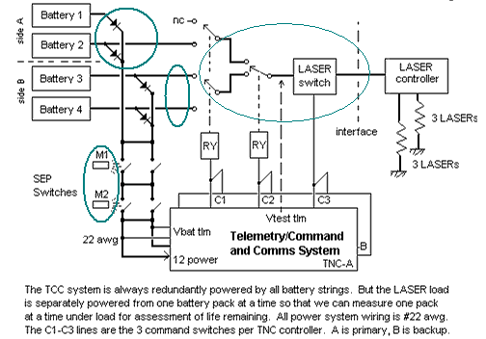

The diagram above did not adequately show three details of the design.
- The dual redundancy of the A and B side laser relays and command switches.
- The change from two magnets to one
- The cross strap on A1/A2 and B1/B2 to resolve voltage drop problems with the lasers

In the figure on the next page, these details have been added in greater detail and each one will be described with respect to its impact on the power system design and safety issues.
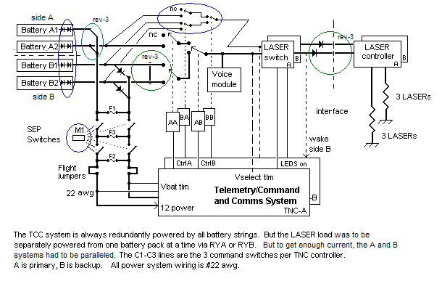

SEPARATION SWITCH MAGNETS: Since ANDE remains inside the CAPE while in the vicinity of the shuttle, and since it was determined that there is adequate EMI suppression by the CAPE, then it was determined at the phase2 PSRP that inadvertent activation of the separation switches was not an RF hazard and only a mission assurance issue. Therefore only one magnet was required to close all four separation switches. But the two cup-cone retention systems were retained to provide dual prevention of rotation.

INADVERTANT ACTIVATION: If the ANDE MAA communications system was inadvertently activated inside the CAPE by a failure of the separation switches or magnet, the following power dissipation issues are addressed.
- Operating current would be about 12 mA average at 16 volts or about 0.2 Watts. This results in an insignificant temperature rise when dissipated through the 50 kG spacecraft.
- Transmitters: The transmitters are protected against activation by additional inhibits. They are not operated unless commanded, a 1 second per transmission software restriction and a 15 second hardware watch-dog timer.
- Lasers: The lasers are protected against activation by additional inhibits, first, the battery selection relays and then by the laser switch.

SMART-SHORT: The worst case failure mode is a smart short that draws maximum rated fuse currents without blowing. This current is about 500 mA per battery box. This value is obtained from the current limit ratings of the seven paralleled 50 mA PTC fuses per battery box. The
Initial rating would be 700 mA for seven fuses, but as the system warms, these fuses show a specified opening at 70 mA at 60 deg C, so this totals to about 500 mA for this overheating analysis per battery box.
The worst case smart short then, would short all battery boxes for a total power dissipation of 2 amps at 16 volts. or 32 Watts for the spacecraft which must be lost mostly by radiation to the ICU/CAPE. The average emissivity of the MAA sphere is about .5 for its 1135 square inches of surface area. The emissivity of the inside of the CAPE is 0.1. The MAA sphere would radiate heat for up to 10 days (240 hours to dissipate the 7500 watt hours of battery capacity). Under this condition and assuming a worst case (hot) for the ICU/CAPE of 45 deg C, the steady state temperature of the MAA sphere would get to about 87 degrees C as determined below. The Lithium cells are specified to 85 degrees C.

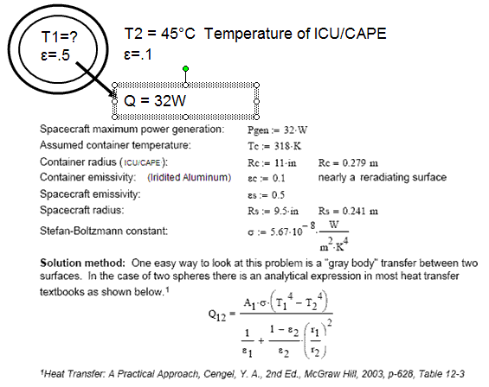
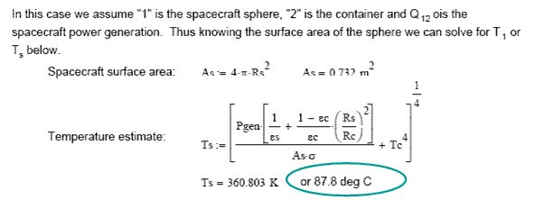

WIRE SIZING: Number 22 AWG wire was used because it is capable of carrying sufficient current to blow any of the 750 mA or 50 mA fuses.

LASER SWITCHING: For simplicity, the dual redundant battery selection and laser on/off command switches had not been fully detailed in previous slides. The diagram above fully fills out the parallel redundancy of the side B switching system to be able to independently select a battery pack and to independently turn on/off the lasers. In other words, both the A and B sides have their own relays. These are added in blue above. Also added to the drawing (in blue) are shown the internal dual-redundant blocking diodes on each of the four battery packs so that it is clear that adequate blocking diodes exist no matter how the battery packs are combined.

CHANGE: There were two changes post-P3PSRP marked as REV-3 on the above diagram.
- The cross strap was removed between the A and B lasers that permitted either side to control all 6 lasers. Now, only the A or B system can only turn on the three A or B lasers.
- The A1 and A2 pair and the B1 and B2 pair were paralleled to provide a lower internal impedance to better meet the instantaneous peak current demands of the lasers

RATIONALE: During functional testing of the ANDE MAA system on 26 May 2006, it was noted that the six lasers could not all be fired reliably due to the high internal impedance of the batteries and limited current available. They would run for several seconds and then enter a power reset cycling mode of about one flash per second.

Although the average power of the lasers is only about 250 mA, the peak current requirement if all 6 lasers happen to fire at once can be almost 2.5 amps for a few milliseconds. With the relatively high internal impedance of the Lithium primary cells (about 20 ohms per 12 volt string), and an additional diode voltage drop in the B side batteries, this brief peak current demand causes a negative going voltage transient that then resets the laser-pulsing-microcontroller causing them to reboot. The following fix solved the problem.

- Separating the A and B side lasers allows only 3 lasers to be operated at half the critical peak current and this mode of operation is reliable. Also we do not lose any of the original dual command redundancy since 3 laser operation is still sufficient to meet mission requirements of attitude determination.

- Strapping the A1 and A2 battery packs and the B1 and B2 battery systems in parallel allows for the three B side lasers to operate from B1 and B2 without the diode voltage drop. Yet the diode drop remains in the circuit as part of the battery life management system.

With these two modifications, six laser operation is possible at least for the first 40% of the mission and then three-laser operation through to the 60% mission life. And by retaining the B1/B2 diode drop for mission life monitoring, we can anticipate when these milestones are reached.

MISSION LIFE ASSESSMENT: Since the discharge curve for these Lithium primary batteries (below) are absolutely flat to the 97% discharge point there would be no way to monitor or manage mission life until the drop began to appear at the 97% point. The diode drop on half of the batteries (B1/B2), forces a 0.5 volt taper from beginning of mission to end of mission as shown in red (below) that should allow us to anticipate mission life and to manage our mission loads to reach the desired one year mission life. Since all four battery systems already have the required internal dual blocking diodes, the presence or absence of these additional taper diodes have no impact on safety. Similarly, whether the various packs are cross strapped, or not, also has no impact other than providing half the internal impedance under peak load.

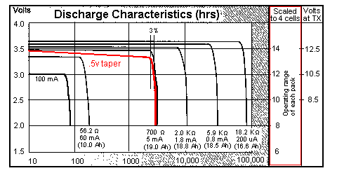

Using the Manufacturers data above, we can infer these three data points as far as the load sharing under these very brief peak currents:

- With 85 mA load, 86% is provided by side A batteries and 14% by side B
- With 925 mA peak load, 90% is provided by side A batteries and 10% by side B
- With 2500 mA peak load, 55% is provided by side A batteries and 45% by side B

The forced early consumption of the A1/A2 batteries will give a 0.5v taper in telemetry system voltage when the batteries are half consumed. This will tell us approximately the half-way point of our mission. Without this 0.5v diode drop, all batteries will be consumed in parallel and we will have no indication of battery capacity failure until the final taper begins at the 97% point of battery life.

By implementing the cross-strapping of the A1/A2 and B1/B2 battery packs, subsequent testing has revealed that the lasers can now be operated reliably from side A or B or both in any combination of 3 or 6 lasers at a time. Further, peak currents through the fuses are halved during laser firing, and none of the battery safety issues have been compromised.

CURRENT LOADS: The average and peak current requirements of the various components of the ANDE MAA system are shown below. Most peak currents are at very low dutycycles on the order of 10% or less.

Standby: Per side: 5 mA and peaks to 70 mA for 1.6 sec every 16 seconds
Operating: Per side: 60 mA and peaks to 500 mA for 1 second bursts every 10+/- seconds
Lasers on: Per side: 350 mA avg with 50 ms peaks to 800 mA about once every 1 to 2 sec.
All –ON both sides: 800 mA average with 50ms peaks to 2 amps every 4 seconds or so. And
worst-case peaks every 10-40 sec to 2.5 amps for 50 ms or so total current of both sides.

Operating and transmitter loads except for the lasers are shared amongst all of the battery packs. The schematic for each of the battery packs is shown below.
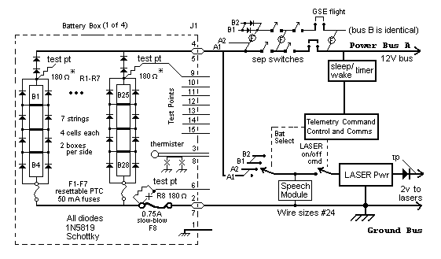

FUSING: Each battery string is protected by a 50 mA PTC fuse in the ground leg. Each battery pack is protected by a 750 mA slow blow series 473 PicoII fuse. The specifications for these fuses are shown below.

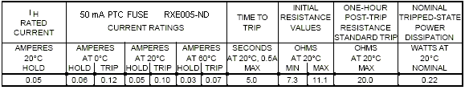

Because of the long time-constant of the PTC fuse and their soft trip points, only the 750 mA slo-blo fuse protecting each battery pack has significant mission impact.
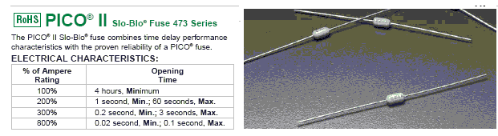

The one second peak Transmitter load splits to 250 mA per battery pack fuse. When the lasers are on, the average current per fuse is increased to about 205 mA average per fuse, well below the 50% fuse rating. During 1 second transmissions every several seconds with lasers on, the average TX peaks to 455 mA for 1 second. Further, occasionally a transmission will occur simultaneously with the 50 ms random synchronization of the 3 lasers for a total peak current of 625 mA for 50ms every several 10’s of seconds. This is 83% of the fuse rating, but is a rare occurrence that lasts only 50ms. The slow-blow fuse is rated to carry up to 200% (1.5 amps) for at least 1 second and up to 2.25 amps for at least 0.2 seconds, which is a safety factor of almost 4 for the peak currents –and- a factor of 4 times longer than the minimum 50ms rare laser peaks. For space, TA-92-038 maximum blow de-rating is 150% , (1.25 amps) so this provides a margin of a factor of two for current and still an additional factor of 20 for the short duration of the peak current.

POWER SYSTEM SAFETY: The revised details of the original block diagram and the two modifications made after the Phase3 PSRP do not impact the safety considerations of the power system as approved by the Safety Panel. The highlighted areas show where the changes were made. The A1/A2 strap was included during the build phase but the B1/B2 strap and isolating the lasers modifications were possible in the wiring harness alone. These two mods were made in June 06 so as to not necessitate any internal configuration changes that would have invalidated previous space environment test results.

Bob Bruninga
US Naval Academy Satellite Lab
410-293-6417

