Operations Documentation for Byonics APRStt DTMF Module rev(c) 30 Nov 2015

Updated 30 Nov 2015 to include Byon’s remberances of what it does too.
Original 23 Jan 2015

This is an attempt at documenting where we are now and where we can go with the combination of the Byonics DTMF daughterboard and APRStt firmware for the TT4. I did a setup of the Byonics module at Dayton in May 2013, and then there was a flurry of activity for a marathon in August 2013, but nothing since (?) Daniel KB3MUN did a lot too, but I haven’t captured it either.. WB3OSZ has fully implemented a lot of APRStt in his Direwolf application. https://github.com/wb2osz/direwolf/blob/dev/doc/APRStt-Implementation-Notes.pdf

Here is my attempt at re-creating the state of thinking (and last known Byonics TT4-APRStt implementation) at that time.

The TT4-APRStt firmware has these setup commands (as of May 2013). It recognized 3 on-air DTMF formats:

DTMF Callsign Only - Put them at the origin (in Dayton) (confirm?)
B0 or B100 - B0 works like B100
B1YX* then Callsign - Puts them on the map at the Y,X location (flea market)
B2YYXX* - Puts them on the map anywhere in Dayton

Byon adds:
- It Re-transmits up to 10 calls in decay algorithm 0s,30s,1m,2m,4m,8m and overwrites oldest
- It sends morse "K" after valid reception
- It supports full and abbreviated callsigns w/ cksums and overlays

APRStt SATELLITE May 2015: The immediate need for the near term is simply adding a GPS input on Port B and then placing that position into the TT-Corral variable. That is where the position for callsign-only calls are generated. This should be quite simple since you aleady have port-B GPS input . See new sections at the end of this HAVE-NOW section…

WHAT WE HAVE NOW: (the remainder of this doc is trying to capture where we are now):

UNKNOWNS: What does it do with callsign-only DTMF now?
Does it implement any kind of SUFFIX call matching?

Here were the TT4-APRStt settings for Dayton 2013:

MYCALL is WB4APR-2
PATH1 is WIDE1-1 Path of outgoing packets
PATH2 is Second hop for outgoing packets

B1XOD is -84 Degrees longitude for the B1YYXX origin
B1XOH is 1524 Hundredths of degree for the B1YX origin
B1XIH is 3 Increment for the hundredths
B1YOD is 39 Degrees Latitude for the B1YYXX origin
B1YOH is 4920 Hundredths of degree for the B1YX origin
B1YIH is 2 Increment for the hundredths

B2XOD is -84 Degrees longitude for the B2YYXX origin
B2XOH is 0 Hundredths of degree for the B2YYXX origin
B2XIH is 100 Increment for the hundredths
B2YOD is 39 Degrees Latitude for the B2YYXX origin
B2YOH is 0 Hundredths of degree for the B2YYXX origin
B2YIH is 100 Increment for the hundredths

BTEXT is ;APRStt-HA*111111z3949.32N/08415.29Wr146.58 MHz (the APRStt posit)
BPERIOD is 600 Beacon Period in seconds

At that time, here are some previous emails that note some of my desires for future TT4-APRStt upgrades:

REQUIRED:

From: Robert Bruninga [mailto:bruninga@usna.edu]
Sent: Sunday, May 19, 2013 12:37 PM
Subject: APRStt Rev-b

Here is the one required revision before I can use it at our repeater. It needs to have the "TT corral" where positionless-calls are placed until a position is received. In my area. The 0/0 position is not in a good place. I need to be able to specify where that "table of calls" appears on the map and which direction it builds and to what scale. Here are the recommended
parameters:

TTCXD - TT corral origin X value in degrees
TTCXH - Hundrdths
TTCYD - TT corral origin Y value in degrees
TTCYH - Hundredths
TTCI - Y increment in hundredths to place the calls above (or below) to
build the table. Note, this parameter can be negative

Having the ability to define the default (TT-Corral) area is all I need initially to begin using APRStt on our repeater fpr general use….

---------------------------------------------------------------------------

REQUIRED FOR May 2015 FLIGHT: SPACECRAFT POSITION Knowledge:

This is simply provision within the TT4-APRStt for the port B GPS position data. This tells the TT4-APRStt where it is and then it uses this position to assign to any callsign-only DTMF bursts heard. The APRS downlink then is a plot of when and where every callsign was heard. This iis existing TT4 code to read the GPS, and simply stuffing that position into the TT-CORRAL origin. Note, we will not actually have a GPS onboard but will have out own processor sending over its estimated position as needed.

NICE TO HAVE FOR May 2015 FLIGHT: GRID-SQUARE TABLE:

We would like to implement the existing B9nn* position format. This is so we can use 4 digit numberic GRID squares instead of having to alpha-numerically encode AA## grid squares using 6 digits. I have analyzed the entire world and there are only 99 “AA” grid squares over land. We put those 99 AA prefixes in a 00-99 deep table and can translate from the first two digits then of an all-numeric grid. So “1519” is actually “FM19” after looking up the 15th entry in this table and finding “FM”. Here is the map. We will provide the exact 99 entries soon.

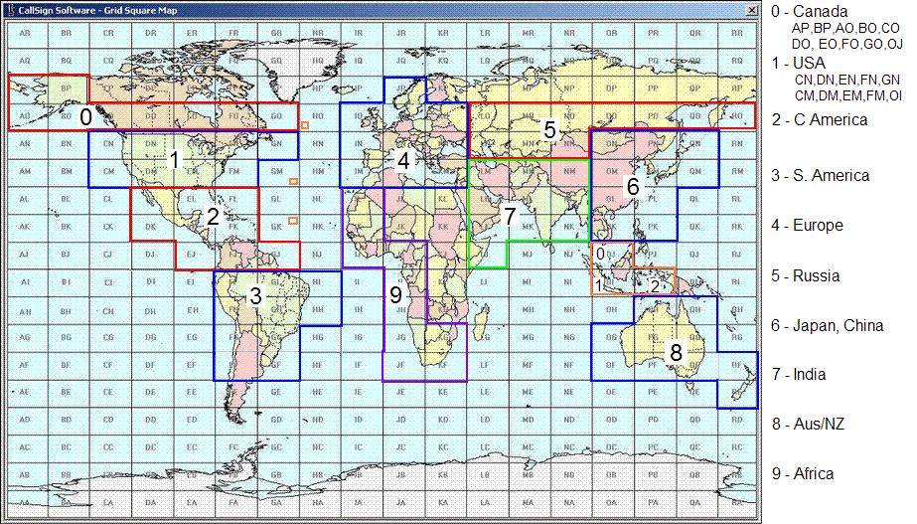

Notice how conveniently each of these major continental areas then has 10 AA grids, so that every grid in the USA for example begins with 1 and every grid in Europe begins with 4, etc… So all you do is implement the original APRStt B9nn* position format with a slight mod. You listen for B9nnnn* but only use the first two digits “nn” to find the actual AA letters from the 00-99 table.

I’d suggest your configuration parameter would be TABLE 10,CN,DN,EN,FN,CM,DM,EM,FM,GM,OI which enters the alpha characters for the table locations 10 to 19. Ten such configuration entries would enter the whole table.

-------------------------------------------------------------------------------
NICE TO HAVE in general in the future…:
-----------------------------------------------------------------------------

LOCATION BEACON (Formats the APRStt beacon that puts the APRStt engine on the map) This replaces the current free-format BTEXT in your code so that users don’t screw up the exact format.

LOCXD - APRStt engine location X value in degrees LOCXH - in hundrdths.
This is what places the APRStt engine on the map LOCYD - APRStt engine location Y value in degrees LOCYH - in hundrdths
TTCI - Y increment

FREQ - 146.58_ <=This is added to the LOCposition to make the APRStt's own beacon
LTEXT - APRStt <= This is added after the FREQ to the LTEXT beacon

TXDP - Transmit delay packet
TXDC - Transmit delay CW
CWS - 20 CW speed in WPM

ACK - R, S or None. R means send "R", "S" means suffix, or none in CW (Change your K to R, its shorter)

AMBIGUITY: All of these APRStt outputs are generally ambiguous by definition. So we need to send the PACKET with the same APRS ambiguity as the inputted DTMF. This is simple to do...

If the position INCREMENT (in hundredths) is greater-than then send position as DDMM.H_ If position increment is greater than 40 then send as DDMM.__

This last one is more complex...

GRID CENTERING: Generallly the default use of this APRStt at a repeater will be to use the +/- 30 mile grid around the repeater since this is the SAME as LAT/LONG minutes. Using B2XXYY* position reporting can then place hams anywhere in range of the repeater to the nearest mile (which is close enough for this default application).

But this only works in 2 digits (as is) if the repeater just happens to be located at 30/30 in the middle of a degree of LAT/LONG. Such is most likely
not the case. So in this case you need two more parameters:

CEN2X 10 <= minutes of the center of usage of the local area CEN2Y 10 <=

These are used to define the approximate CENTER of the LAT/LONG grid where users will be entering their XXYY locations (for 2 digit reporting).
Again, if the center is 30/30,. Then XX and YY can be in the range of 00 to 59 minutes and nothing needs to be done. But lets say the center of interest (often the location of the repeater) is say at 10/10 lat/long minutes, then an XXYY input from the user from 00 to 39 can be used just fine as is, but when the user enters "40" this is now more than 30 away from the center and so 1 DEGREE must be subtracted from the latitude so that it is "40" in the next lower degree (which is 30 minutrd below the center.

I think the math for translating to DDMM.hhN/DDDMM.hhW is like this:

IF CEN2X<30 then: If XX > CEN2X+30 then XDeg=XDeg-1
IF CEN2Y<30 then: If YY > CEN2Y+30 then XDeg=XDeg-1

IFCEN2X>30 then: If XX < CEN2X-30 then XDeg=XDeg+1
IFCEN2Y>30 then: If YY < CEN2Y-30 then XDeg=XDeg+1

