Low Altitude Balloon Mission - Design
This document derived from the EA-470 PSAT/Balloon Engineering Flight Test

MISSION: Flight test the PSAT C&DH and Transponder Comm system using a balloon launch system. The test will also include a camera sensor for imaging the ground view and a mobile ground station for flight tracking and data collection as well as payload recovery. Due to the mass and short duration of this flight, this is considered a low altitude mission.

Flight Test Payload: Flight test of these PSAT flight systems:
MT-TT4 comms board - From Byonics.com. Provides telemetry, serial port command/control, comms transponder .
Parallax CPU: For decoding command, primarily camera control and string cutter
String Cutter: To cut lose the payload before crossing the Atlantic or avoid other water
Camera : Flight test the NTSC camera with 2.4 GHz link system
Power budget:
FAA Rules: The FAA rules for Balloon flights require advance notification for the following conditions:
FAR 101.1a4(i): Carries a payload package that weighs more than four pounds and has a weight/size ratio of more than three ounces per square inch on any surface of the package, determined by dividing the total weight in ounces of the payload package by the area in square inches of its smallest surface;.
For our mission: W/S(bottle cap)=20.4 oz/in^2; W/S(bottle’s base) = 2.3 oz/in^2
FAR 101.1a4(ii): Carries a payload package that weighs more than six pounds.
For our mission: Mass is 230 grams (about 0.6 lbs)
Mobile Ground Station: For tracking the balloon, viewing and recording camera video, testing PSAT comms transponder, chase and recovery of payload. The following equipment must be integrated into the vehicle:
2.4 GHz camera receiver, video monitor, and video recorder
2.4 GHz dish antenna and AZ/EL rotor controller
Beamwidth of antenna (Ѳ) = 7.2 degrees
AZ/EL rotor schematic: In order to interface to the antenna rotor, an understanding of the rotor conttols are necessary. In the below schematic, you can see the two position feedback poterntiometers in the upper right. For our control system the pots are disconnected from the existing controller and are used to drive an I/O pin of the Parallax CPU directly. A separate jumper connector can be used to restore normal operation when the special AZ/EL processor is not in use.
The outputs to the rotator motors are shown in the lower right driven from the four relays in the lower left. These are connecte to the Left, right, up, down pins of the seven pin connector shown in the lower right above the motors. The output of our CPU drives those pins.
115 VAC power system for van: Several systems in the van will require 115 VAC power. This will be obtained from a 1000W pure sine wave inverter from the van’s 12v power system. Heavy cables to the battery are necessary. Just 100 watts at 115 VAC will need 12 amps at 12 volts.

Ground Station packaging
Balloon:
Track Prediction:
Size, mass, lift, filling: (Thomasson)
The balloon requirements have been changed to a flight altitude of 5000 feet. Because of this, we can use the Mylar balloons for the flight test, and not have to spend both time and money ordering more Totex balloons to replace the old ones currently in stock. The volume we fill the balloons to depends on the pressure altitude at 5000 feet, as well as prevailing weather conditions.
First, the Mylar balloons are UV resistant, constant pressure, rigid volume low cost, relatively high mass lifting platforms. They weigh 39 grams each, and when filled with Helium, can lift 107 grams of mass (minus their own weight), which provides 68 grams of free lift per balloon. Helium loss over the course of this relatively short mission is almost negligible. The total number of balloons required for this mission is dependent on how much mass the payload is. There needs to be a certain amount of left over free lift in order to ensure a fast enough ascent rate, but not so much that the desired pressure altitude is overshot.
The operating altitude needs to be in the vicinity of 5000 feet. The pressure at this altitude is 12.2 PSIA. This leads to the determination of the number of balloons by determining the maximum mass per balloon sustainable with regards to the amount of available free lift.
Maximum Added Mass per balloon=(12.2/14.7)*107-39
This allows at most the addition of 49.8 grams per balloon. Keep in mind that operating at this maximum would result in a slow ascent rate, as well as leave little room for error.

Mass budget overall: (Thomasson)
parachute:
coke bottle: 36.8 grams
comms_board: 92 grams (59 without connectors)
gps: 19 grams
balloon: 39 grams per balloon (5 balloons)
string:
tape:
camera: 15 grams
Power Supply: 31 grams per battery (2 batteries)

191.8
about 230 grams total
ascent rate requirement?

m_payload+m_balloon=Volume_Balloon*(density_air-density_helium)

Power budget Overall: (Thomasson)
Receiver: 8 mA (all of the time)
Transmitter: 340 mA (1/30th of the time)
TT4: 80 mA ( all of the time)
GPS: 65 mA (all of the time)
Camera: 150 mA (all of the time)
Leads to: 315 mA
860 mA for 5 seconds, (1/12th): 72 mA one time
Total usage is 315 mA *3 hours + 72 mA: 1017 mA
One nine volt battery provides 1200 mAH
The mission life is about three hours, providing 400 mA per hour for three hours. Therefore, we can get away with using one lithium 9-Volt battery for this particular mission.
This cuts it pretty close.

Number of Balloons Determination: (Thomasson)
The payload mass is about 230 grams
The maximum added mass to each balloon to reach 5000 feet is 49.8 grams
This would suggest 4.62 balloons
This leads to 5 balloons
This shows 14.7*(39g+(Payload/4 Bal))/107=11.22 5 balloons at 230 grams payload, 11.68 PSI
This shows a new height of just under 7000 feet. 6245 feet
Wind Speed Prediction: (Thomasson)
Using the Reynolds criteria, without a major system going through, at 5000 feet, the balloon should travel roughly 17 mph. However, as indicated by the chart below, a front is moving through. In addition, because we will use the fifth balloon, the height will be around 6245 feet. This indicates a slight increase in wind speed about 21 mph. (18.6 knots) Taking ground wind speeds into account, (13 knots), the balloon can travel 31 knots on average. Gust are predicted to be up to 20 knots. Taking temperature variations into account (weather should be 64 degrees Fahrenheit). Because our basic model uses room temperature assumptions, and this is cooler than room temperature, the balloon should go slightly (higher?) than even the 6245 feet figure.
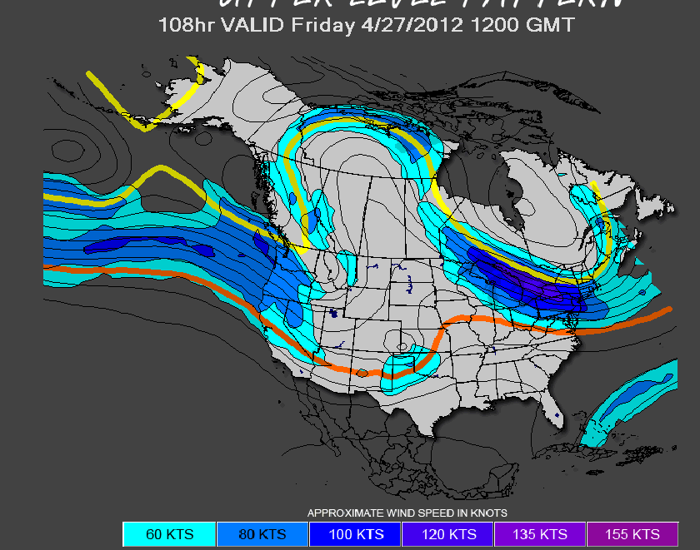
Reynolds Criteria is Velocity=Velocity_ref*(Height/Height_ref)^0.142
A reference velocity and height of 5 meters per second and 10 meters was used (respectively).

String Cutter Load Test (Garcia):
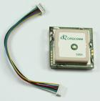
To determine if there was sufficient peak current available from the Lithium battery, a 9V battery was tested with the 10 ohm burn resistor. The battery was measured at 9.04 V before testing the resistor. During the test, the battery dropped to 8.02 V. This indicates about a 1 ohm internal resistance of the battery. To this, an additional 1 volt drop will occur over the switching transistor. Further since this burn operation will occur late in the flight when there has been additional voltage loss, the design goal must be for a successful burn with only 6 volts at the resistor. Further testing of the string cutter at 6 volts will be conducted prior to the flight test.
Balloon GPS Module:
This is the receiver module found inside the GPS2 (no case or DB-9 cable), for use in embedded and ultra light weight applications. It weighes 0.7oz, comes with a 4" interface cable and outputs both TTL and RS-232. Wiring is yellow:TTL data from GPS, blue:TTL data to GPS, red:Vcc 3.3 to 5 volt DC, black:Ground, green:RS-232 data from GPS, white:RS-232 data to GPS. Size is 32mm x 32mm x 9mm, 0.7 oz.
Van GPS unit:
This unit is the same as used in EA-467 lab. Serial GPS data and grouind wires are used as shownhere. This data provides the $GPRMC sentence data that includes LAT and LONG data as well as CSE and SPEED. These elements are used in the calculation of the AZ and EL to the balloon payload.
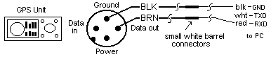

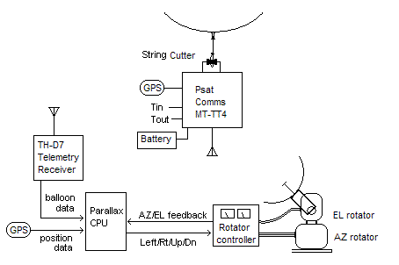
Mobile Antenna Tracking:
The most significant problem in the antenna tracker is the serial input routine for reading the local van GPS data and the remote GPS data from the balloon. We use the SERIN command:

SERIN 9,16572,2000,NoVanData,[WAIT ("GPRMC,"),SPSTR 50]
'This is the serial input command at 4800 baud using pin 9.
'it monitors the comm port for WF ms for data. If no data after WF ms, then
'it jumps TO theNoVanData routine. If there is data,
'it waits for exactly "GPRMC" and puts the next N bytes in ScratchPas RAM
'Following offsets in SP memory for these values

'data locations 2 3 3
' 9 1 2 8
'$GPRMC,090644,A,3859.482,N,07629.014,W,000.0,360.0,050140

Scaling to Integer Math: The second significan issue with the processor is the need to use 16 bit integer math only.
'LAT/LON is only square at theequator. We can square it up anywhere by
'multiplying the longitude by the COS of the LAT.
'The Cosine of 39 deg LAT is 0.777 which is also 7/9 integer
'Next, to scale LAT/LONG precision to 16 bit signed values, we can subtract
'a local origin to give values of +/- 10 degrees (+/- 600 miles). By giving
'3000 points per degree, we can stay below the +/-32,768 limit of precision.
'To convert into our math, take local LAT (LAT-35)*3000. Result +/- 30000
'to convert Mins to our math, take MMmm/2. Gives scale +/- 3000 per deg
'For longitude we do the same but by 7/9ths of 3000 or 2333. Then for
'longitude minutes we multiply by 1/2 * 7/9 or basically 7/18

POST-Flight Lessons Learned:
Avoid things pulling UP from tangling with things hanging down. The failure mode on this flight was a burst balloon hanging down and tangling with the parachute also hanging down.
Add a burn cutter for one or more balloons, no parachute. Loss of lift will safely and slowly descend the payload. In addition, the balloons remaining behind will act as a flag for balloon locating.
We need a more sensitive pressure gauge adapter in order to more accurately fill balloons to the same pressure so that one does not over pressurize and pop, shortening the entire mission. The fill box still makes some sense…
Design a method of launching balloons regardless of wind conditions. We actually launched in 10 MPH or higher (gusts to 20). That would be impossible for a latex balloon, but the Mylar balloons seemed quite robust.

Altitude pressure table:
Altitude Above Sea Level |  | Absolute Barometer |  | Absolute Atmospheric Pressure
0¹⁾ | 0 | 29.9 | 765 | 14.7 | 1.03 | 101
500 | 152 | 29.4 | 751 | 14.4 | 1.01 | 99.5
1000 | 305 | 28.9 | 738 | 14.2 | 0.997 | 97.7
1500 | 457 | 28.3 | 724 | 13.9 | 0.979 | 96.0
2000 | 610 | 27.8 | 711 | 13.7 | 0.961 | 94.2
3000 | 914 | 26.8 | 686 | 13.2 | 0.926 | 90.8
4000 | 1219 | 25.8 | 661 | 12.7 | 0.893 | 87.5
5000 | 1524 | 24.9 | 637 | 12.2 | 0.860 | 84.3
6000 | 1829 | 24.0 | 613 | 11.8 | 0.828 | 81.2
7000 | 2134 | 23.1 | 590 | 11.3 | 0.797 | 78.2
8000 | 2438 | 22.2 | 568 | 10.9 | 0.768 | 75.3
9000 | 2743 | 21.4 | 547 | 10.5 | 0.739 | 72.4
10000 | 3048 | 20.6 | 526 | 10.1 | 0.711 | 69.7
15000 | 4572 | 16.9 | 432 | 8.29 | 0.583 | 57.2
20000 | 6096 | 13.8 | 352 | 6.75 | 0.475 | 46.6
25000 | 7620 | 11.1 | 284 | 5.45 | 0.384 | 37.6
30000 | 9144 | 8.89 | 227 | 4.36 | 0.307 | 30.1
35000 | 10668 | 7.04 | 180 | 3.46 | 0.243 | 23.8
40000 | 12192 | 5.52 | 141 | 2.71 | 0.191 | 18.7
45000 | 13716 | 4.28 | 109 | 2.10 | 0.148 | 14.5
50000 | 15240 | 3.27 | 83.6 | 1.61 | 0.113 | 11.1
http://www.engineeringtoolbox.com/air-altitude-pressure-d_462.html

