EA-467 LABsat and PCsat Final Operations (rev-b) Fall 2008

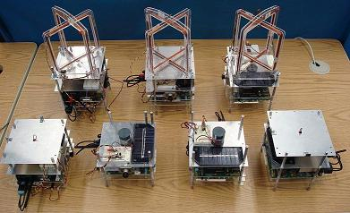

OBJECTIVE: This is the final lab of the EA467 series (on the last day of class, and first day of full-sun for PCsat) where you will combine all that you have learned into a final satellite operations test. The operations scenario is that five of the LABsats similar to those above are hung from strings scattered around the campus at various unknown locations, in an unknown state, and unknown attitude except for +Z down. Your lab team will have a chance at each ground station, to operate each satellite, use telemetry to determine its attitude, activate the ADCS to orient to the sun for max power and operate the imaging system to find out where it is from ground truth as follows:
- First we must recover PCSAT-1 that should enter full sun TODAY! Then proceed with lab:
- Activate the ground station on the correct command and control frequency
- Logon to the satellite using the remote-logon and password sequence
- Activate 10 second telemetry, and observe battery voltage for nominal ops.
- Monitor solar X and Y currents and using ATAN2, estimate the spacecraft’s Sun Attitude
- Activate the Imaging system. Rotate your ground station antenna for optimum signal.
- Sweep the image sensor FOV using the ADCS to locate the spacecraft via ground truth.
- Stabilize +Y to Sun Pointing for maximum power using the ADCS to rotate as needed.
- Command OFF the camera and ADCS when max power is achieved and the spacecraft is stable.
- Secure the ground station (^C to command prompt: and “D” to disconnect)
- Move on to the next LABsat Ground Station and repeat these operations keeping the location secret.
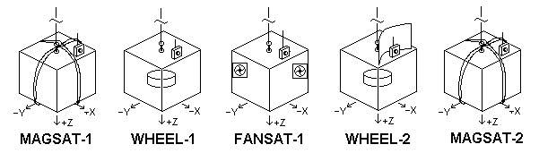
SPACECRAFT: The five spacecraft and their associated Attitude Dynamics and Control System (ADCS) are shown above. Each spacecraft has an imaging camera on the –X face and has its largest solar panel on the +Y face. In the table below are the additional specifications for each spacecraft:

Satellite | Volts | Command Frequency | Image Sensor Link Frequency | Attitude Dynamics and Control system | Ground Stn. Ant. Gain
FANSAT-1 | 8v | 145.825 | Lband Ch1 1080 MHz | Thruster | 3 dB omni
MAGSAT-1 | 8v | 147.825 | Lband Ch2 1120 MHz | Magnetorquing | 3 dN omni
WHEEL-1 | 8v | 435.925 | Lband Ch4 1200 MHz | Momentum Wheel | 6 dB reflector
WHEEL-2 | 12 | 437.350 | Sband Ch1 2405 MHz+10 dB | Momentum Wheel | 3 dB omni
WHEEL-4 | 12 | 438.350 | Sband Ch2 2435 MHz | Momentum Wheel | 18 dB dish


GROUND STATIONS: There are five ground stations, one for each spacecraft. Each station has a PC, radio, and modem for telemetry command and control (TC&C). Each ground station also has a microwave L or S band imagery receiver and video monitor with each on a different RF channel. The TC&C channels are separated on VHF and UHF bands and the imaging systems on L and S band for Electro Magnetic Compatibility (EMC) to minimize mutual interference.
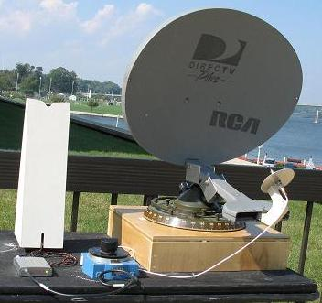
ANTENNAS: Each ground station has one of the antennas from the Antenna lab that is appropriate for the frequency band and range for its satellite. Two links will use small 18 dB dishs, two will use omni’s and one will use a dipole with reflector
COMMAND LINK: Open the protected command link to the spacecraft using the remote-logon callsign which is the same as the spacecraft telemetry callsign but with “10” added to the ID number. To do this, at the ground station “cmd:” prompt, type C SATNAME-1n for your LABsat SATNAME-n.
As in previous labs, the satellite responds with three lines of 6 digits that you must match from the “secret” password string (“gonavy”). Type these 6 characters followed by the ENTER key and if successful, you will get the spacecraft’s “prompt:”. From the prompt: you can send any of the remote control commands to the spacecraft Telemetry, ADCS or Imaging Camera systems.
COMMANDING: As you recall, The CTR A/B ON/OFF commands activate your CW and CCW attitude control such as for the momentum wheel shown below right. These commands also operate in the pulse mode with CTR A/B N for values of N between 1 and 20 in increments of 0.2 seconds each. The Lens-Camera can be turned on/off with the L ON/OFF commands.
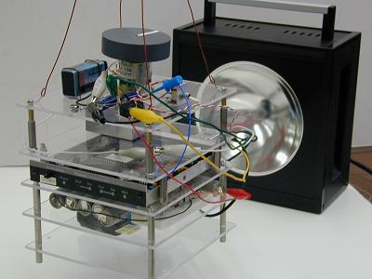
TELEMETRY: You can set the Telemetry rate using the TE N command where N is in ten second increments. Set TE 1 for the highest update rate (10 seconds) for operations with the MAGsats because they are dependent on Sun currents for attitude estimation. For the other satellites, 20 secs is OK. The spacecraft have the following channels:
Ch1 – Battery Voltage (in tenths of volts)
Ch2 - X solar array current (0 to 100)
Ch3 - Y solar array current (0 to 100)
Ch4 - 000 (not used)
Ch5 - Image Camera Current (in 10’s of mA)

ELECTRICAL POWER SYSTEM: As in the EPS lab, you should not deep-discharge below about 1.1 volt per cell. Further the 5 volt series regulator for the Modem requires at least 6.5 volts input to remain in regulation. Therefore you should monitor your spacecraft voltage and cease operations when the bus gets below 6.6 volts on the 8 volt systems (6 cells) and 9.9 volts on the 12 volt systems (9 cells).
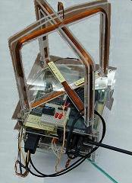
MAGSAT-1 and MAGSAT-2 (crashed):
These two magnetorquing satellites are configured the same as in the 3rd ADCS lab. Each satellite has two orthogonal 20 ohm coils wound from 100 turns of #30 wire operated from the 8 volt bus. As measured in that lab, the Z axis moment of inertia and torque developed from the coil can result in an angular velocity of about 2 degrees per second, but only when the proper coil is activated and only when it is orthogonal to North Magnetic Pole as shown below.
These A and B coils (X and Y) may be individually activated in their positive direction only by using the commands CTR A ON or CTR B ON. And either coil can be turned off with the CTR OFF command. Unlike in the ADCS lab, you cannot see the spacecraft, so you have to rely on your ch2 (X) and ch3 (Y) solar array current telemetry to determine the spacecraft attitude relative to the Sun as shown below.
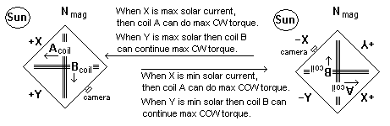
The +X/–X and +Y/–Y solar panels are wired the same as in the attitude estimation lab, so that the telemetry gives a maximum positive value near 255 when the sun is directly on the + face and is close to zero when the sun is on the – face. If the solar panel + or – faces see no sun, then the telemetry for that axis is mid scale at 128 or so.
This unique set up and alignment of the Sun, camera, coils and solar panels should make it easy for you to fly this spacecraft blind by the seat-of-your-pants while watching the telemetry and controlling the coils.

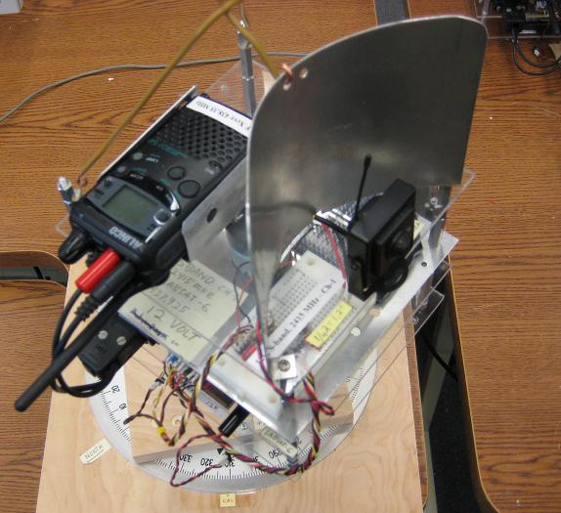
WHEEL-1 (8v) , WHEEL-2 (12v) , and WHEEL-4 (12v):
These LABsats have their momentum wheel connected to the CTR A and B commands so that you can rotate the attitude about the Z axis CW or CCW. Use the CTR A N or CTR B N commands to give discrete rotations. A maximum pulse value of N = 20 will give you about a 45 degree rotation in the given direction. WHEEL-2 has a parabolic reflector behind the S band antenna to give +10 dB gain to the S band image link in the –X direction. This will greatly improve the image link when –X is pointed at your ground station.

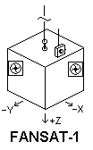
FANSAT-1 (8 volts):

FANSAT-1 has two thrusters, one to rotate CW using the CTR A commands and the other to rotate CCW using the CTR B commands. As measured in that lab, the Z axis moment of inertia and torque developed from the fan thrusters can result in an angular velocity of about 5 degrees per second from an impulse of CTR A 20 for example.

Lab Report (Final for the semester): None required! Just report on your 3/5 card your estimate of the location of each satellite and turn it in for final score. Have fun!

Bruninga, Thienel, Stevens
SCORING SHEET

Section: ______________
Team Members: ______________, _________________

MAGSAT-1: Starting Voltage: __________, Ending voltage _____________
Location: ____________________________________________
Peak X solar: ___________, Peak Y solar: __________________

WHEEL-1: Starting Voltage: __________, Ending voltage _____________
Location: ____________________________________________
Peak X solar: ___________, Peak Y solar: __________________

WHEEL-2: Starting Voltage: __________, Ending voltage _____________
Location: ____________________________________________
Peak X solar: _____N/A__, Peak Y solar: ________N/A______

WHEEL-4: Starting Voltage: __________, Ending voltage _____________
Location: ____________________________________________
Peak X solar: _____N/A___, Peak Y solar: __________________

FANSAT-1: Starting Voltage: __________, Ending voltage _____________
Location: ____________________________________________
Peak X solar: ____N/A_____, Peak Y solar: _______N/A________

