Psat and the APRS Space Network

Bob Bruninga, WB4APR
TAPR/ARRL/AMSAT/USNA
Annapolis, Maryland
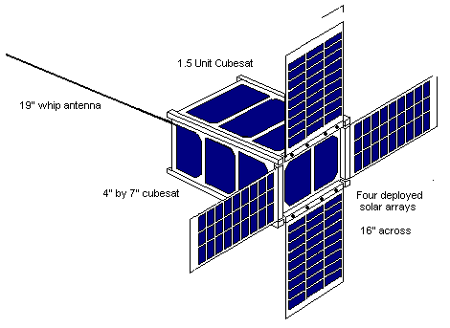
Abstract: The next APRS satellite is manifest for launch in the spring of 2011. This will be our first cubesat, but with four deployable solar panels we should have plenty of power budget for an APRS VHF as well as a PSK-31 ten-meter transponder. APRS is a communications text-messaging and information receive system for the distribution and display of relevant immediate information of use to the mobile or portable operator. Via the APRS Amateur Satellites, this capability is extended world-wide from a radio in the palm of your hand.!

Many people have been mislead into thinking of APRS as a vehicle tracking system and thus dead-end their thoughts about how to use this 2-way communications capability for universal text messaging. As originally designed, APRS focuses on the receipt and display of relevant ham radio information and text-messaging and Email from the palm of your hand and APRS represents the epitome of ham radio. With our congested and shared AMSAT uplinks, the ability to transmit your relevant QSO information through the satellite in about 1 second is very valuable to the use by large numbers of operators. Most cubesats and other university satellites are capable of serving as APRS transponders, even while they are performing their primary mission. We need to encourage such operations, preferably on the one 145.825 channel for synergy with other satellites and the global network of ground stations.

Key Words: Psat, APRS, ham radio text messaging, Satellite Objects

APRS in Space: No matter where you are on the planet from about 2001, if you had your APRS radio with you, there was a communications opportunity on the order of every few hours or so via the APRS satellites (ISS, PCSAT, PCSAT2, ANDE, RAFTm GO-32, ECHO and some cubesats. You can uplink to these satellites with as little as a 5 Watt HT and whip antenna or via your mobile with omni antenna. There is no reason why we cannot support many more APRS transponders on the many cubesats and other small student and university satellites on 145.825 MHz.

Most hams even in 2010 do not realize that APRS operators have been able to use their radios for local/global text messaging and Emails for the last 10 years? This was long before the present teen-ager craze of text messaging on cell phones. See http://aprs.org/aprs-messaging.html [1].

Text messaging is as fundamental to ham radio communications as CW was in Marconi’s time. Minimum communications is also important when there is a local situation, emergency, disaster, or simply when something exciting is happening that you want to share with others. We equip our cars with amateur radio technology, but are we really using it effectively? With APRS satellites able to work with mobiles and omni antennas, it is important that AMSAT operators be aware of this communications capability.

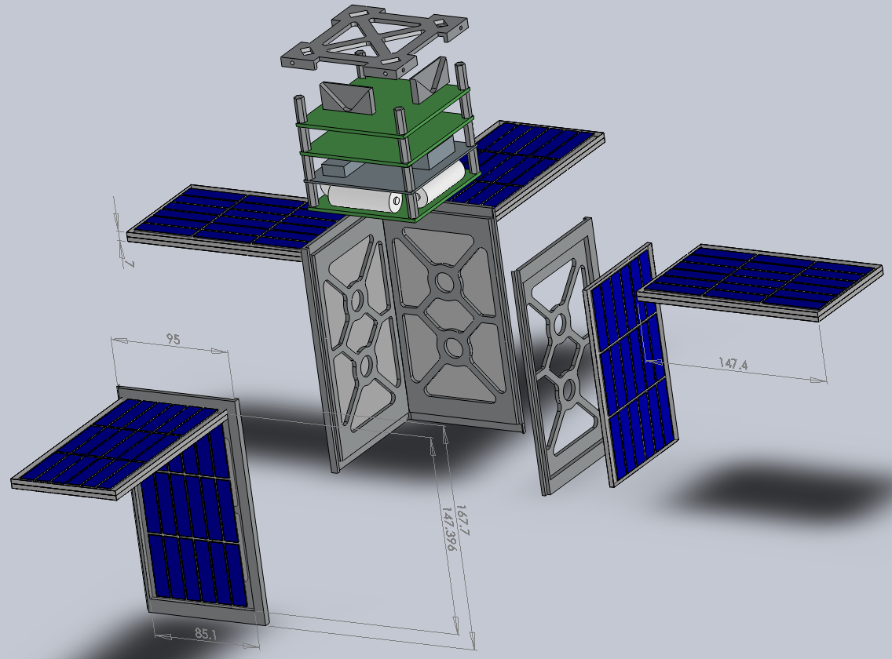
ParkinsonSAT (Psat)

Psat is the next APRS satellite design from students at the US Naval Academy. Although we have built 5 previous APRS satellites, only the original PCSAT-1 is still in orbit because all the others were deployed from the Shuttle and at the low altitude, have re-entered. PCSAT-1 (W3ADO-1) is partially operational when ever sun angles are optimum a few times a day; and you can see its live downlink on http://pcsat.aprs.org [2].

Psat will be our first CUBESAT designed around the 4” cubesat concept developed by Bob Twiggs at Stanford over a decade ago and now organized by Cal Poly. Instead of a single 4” cubesat, our design consists of two 1.5 unit cubesats to completely occupy a single P-Pod Deployer. In order to close the link between mobiles and the satellites, both using OMNI antennas, we are using a 4Watt packet transmitter. There is insufficient power available on a cubesat to maintain this power budget. So Psat includes four deployable solar panels to more than double the power available. See the Psat design page [3]

Attitude Control System

Of course, the deployable solar panels are of no value unless they can be pointed directly at the sun. This requires and Attitude Dynamics and Control System. The ADCS consists of a sun sensor, a magnetometer and a set of three orthogonal torque coils. It senses its attitude with respect to the sun and senses its orientation with respect to the local magnetic field, then it computes the needed torque to apply to the proper coils to not only bring it into alignment with the sun, but also to maintain a slow spin about the sun axis so that it will coast through eclipse and be reasonably pointed at the sun when it comes back out of eclipse.

We are using a very simple Parallax BASIC Stamp processor for all onboard functions and ADCS. This is a challenge in a processor with only 16 words of RAM and only 2K of program memory. Fortunately, the high-end BS2pe processor extends the capability by allowing 8 different pages of 2K program space and adds 128 bytes of scratchpad memory. The other challenge is that there is no floating point and multiplication and division are limited to positive integers only!

APRS Transponder: Inherent in any AX.25 packet system for spacecraft is the abilty to support the APRS digipeating function. Our previous satellites simply flew a conventional TNC (Terminal Node Controller) in space, and not only did this provide the APRS function, the TNC’s also included remote-sysop control capabilities and some analog telemetry inputs so the stock TNC’s processor without any significant modification could be used for spacecraft command and control as well. What made this new Cubesat version possible was the recent off-the-shelf combination of a full function TNC and micro transceiver in the Byonics MT-TT4 Microtrack APRS system. The change in size from the original PCSAT 1 and 2 APRS transponder tray and the new Microtrack MT-TT4 is shown in the figures below:

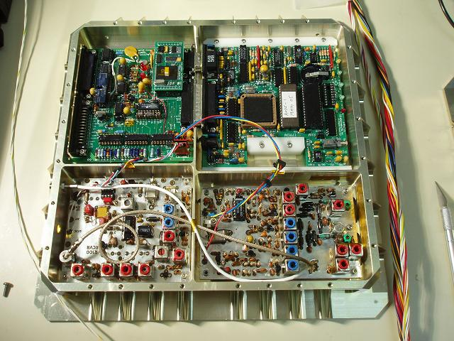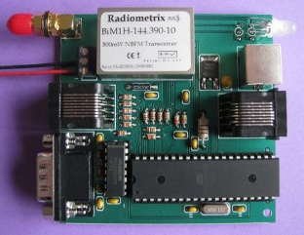

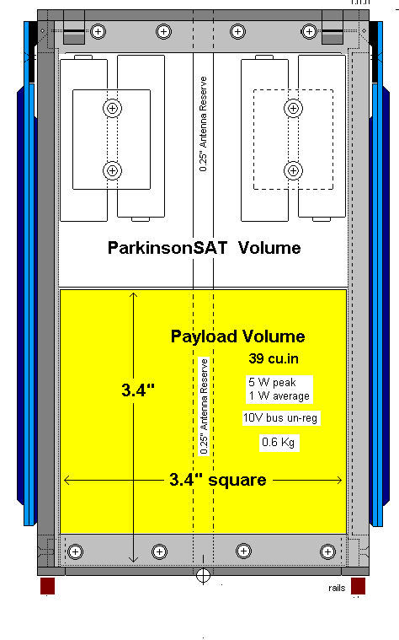
Auxilliary Payload (Ten Meter PSK-31 Band Monitor):

The APRS relay function is inherent in the basic communications modules and TNC of the Psat bus. Therefore, that function complete with battery power system and ADCS fits in less than half of the available 1.5Unit cubesat. This allows the other half to be used for auxiliary payloads. One such potential amateur payload is a PSK-31 Transponder. Using PSK-31 on the uplink allows as many as 30 or more simultaneous users to use the narrow 3 KHz uplink bandwith into an SSB type receiver. The combination of all these signals is then downlinked on a UHF FM channel so that everyone can see and hear the combined channel. This FM downlink also eliminates the significant +/- 9 KHz Doppler of UHF on the PSK-31 signals, though it does require the ground station operator to re-tune his FM receiver a few times during the pass.

Full Duplex PSK-31 Operations: A very unusual design for this transponder is that the operators and users are operating full duplex on PSK-31. This way they can see their own signal withing the combined downlink just like everyone else. The station can then control the level of his uplink and see how it compares with others. Also, being full duplex, he can maintain as many as 30 simultaneous
Conversations as fast as he can type. Think of it as a shared 2-way comm channel with everyone seeing everyone else in real time.

The Doppler at 28 MHz however is still present and over the duration of a pass, it can be as much as 600 Hz or at the center of the pass, as much as 6 Hz per second. Hopefully this Doppler rate change can be accommodated in the various PSK-31 DSP demodulators.

We have tried the PSK-31 transponder on 2 previous missions. In PCSAT-2 on the exterior of the ISS, the experiement was not turned on for several weeks, and then when it was, it only worked for a week or less. Uplink power level requirements increased to where even a kilowattt uplink could not be heard after a week. Post flight analysis indicated the problem. The HF uplink antenna was broken cleanly in half and was only held in place by the insulating Kapton tape. Without an uplink antenna, the experiment was useless. The other experiment was on RAFT. But RAFT suffered a separation anomaly and the HF antenna deployment was compromised.

We are calling this PSK-31 transponder a “propagation monitor” because we have chosen the uplink channel to be the center of the ten-meter PSK-31 activity to assure that there are lots of signals to monitor instead of a dedicated satellite uplink channel. This ten meter PSK-31 monitor system allows users to monitor these signals from above the ionosphere where propagation effects will be noticeable. The downlink from the satellite is in the UHF satellite segment on 435.275 MHz where the entire passband can be seen.

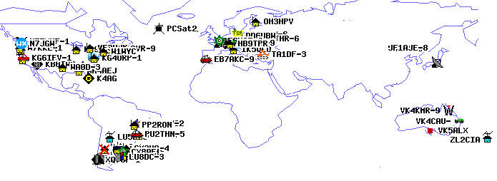
Ground Terminal Equipment for APRS: The world map above shows the typical downlink display as captured by PCSAT-1. These stations can be either fixed, mobile, or remote data sensors. But for mobile satellite operation, there are now a variety of fully integrated APRS radios as shown below. Shown left to right, first, in 1998 was the full duplex Kenwood D7 and then the D700. Then the DR-135 with add-on HamHUD or Argent Data systems TNC to give it an APRS display capability, and then in 2007 the fully capable D710 and recently the Yeasu VX-8R family and mobile FTM-350 (not shown). On the right are the two new HT’s, the D72 and VX-8G both with built-in GPS! The D72 continues the D7 full duplex capability for full function hand portable Satellite Communications.

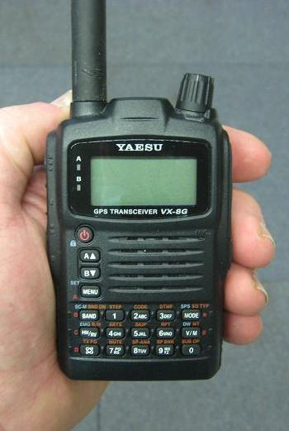
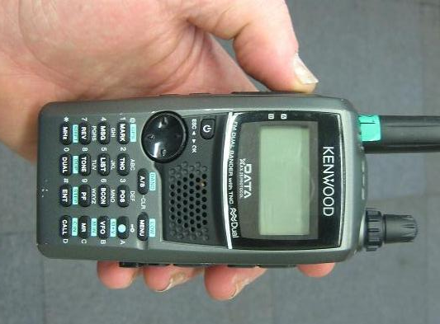
RADIO SETUP FOR SATELLITE OPERATION:

The D700/710 series radio has 5 independent system configuration memories so that you can easily switch between terrestrial and satellite operation with the press of a button. Typically the mobile operator will have one configuration for local commuting, another for the open road, another for mode J Satellites and another for Mode B satellites. These modes automatically configure the proper uplink and downlink band as well as configure the internal TNC to 1200 or 9600 baud and also for cross band operation.

Common APRS Settings: The common convention is to set your terrestrial callsign with an SSID of –7 for a handheld, and –9 for your mobile. For satellite operations use the SSID of - 6. The reason to change the SSID is so that as your APRS data is received into the global APRS internet system (APRS-IS) those packets that went via the satellite will be separately logged compared to those via the terrestrial network.

Most of the APRS menu items are self explanatory, but the most important setting not found in the APRS menu is under the RADIO-DISPLAY menu where you should set the DISPLAY-MODE to 3. This puts the APRS soft-keys on the front panel for rapid access to the APRS LIST and BEACON buttons which are the most useful to the APRS traveler and satellite operator. Without this setting, APRS functions are hidden from the front panel and are not as convenient as they should be. The D710 has a hot key to toggle between soft key menus without the press-and-hold function on the D700. There are numerous web pages with suggestions on setting up the various APRS radios for optimum APRS [4].

APRS Internet Gateway System:

Although APRS is a local information resource, it has global connectivity via the free bandwidth of the internet as shown in the figure below. The primary function of the Internet backbone is to allow the capture of all satellite packets for display and also for end-to-end messaging between any two users by simply knowing callsigns. All APRS packets go into the global channel and are available on-line, but only end-to-end messages come back out to RF for the intended recipient.

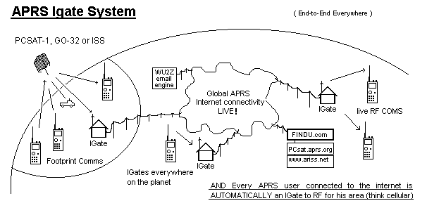

GLOBAL REAL-TIME AND SATELLITE MESSAGING: Although APRS on RF is only a local or single satellite footprint system, it is globally connected via the IGate system for station-to-station messages. APRS has had local and global text messaging for 10 years. This is because all APRS messages transmitted anywhere all get captured into the APRS-Internet system (APRS-IS) by home stations or satgates linked to the internet. If any such Igate anywhere sees the recipient of your message in its local RF area, it will automatically pull that live message packet from the APRS-IS and send it in real time to RF to the targeted user. His system will generate an ACK and the ack will travel the reverse route to the sender in real time. This is not Email. These messages are live. If the recipient is not on the air, the message dies. No routing information is needed, just the sender and receiver callsign. If both stations are on the air anywhere in the Global APRS system, their packets get to each other without any prior routing or address knowledge required. Messages up to 45 characters show up nicely on the D7 display as shown in the next two figures.

APRS messages are global and real time, as long as both stations are on the air. This message (below) is not to another callsign, but to the pseudo-callsign of Email. This special call will be captured by the APRS-IS and turned into a standard Email for delivery to the indicated recipient. This message was a test during a satellite pass.

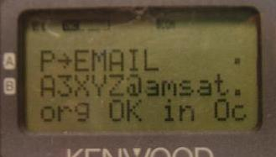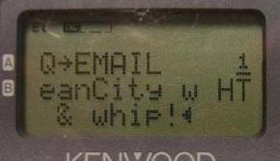

EMAIL: In addition to live real-time global messaging, you can also use APRS to send one-line email to anyone from your mobile, complements of the APRS email Engine maintained by the Sproul Brothers, WU2Z and KB2ICI. Simply address your normal APRS message to “EMAIL” and enter the email address as the first word of the message line. Their WU2Z Email Engine at Rutgers University (see figure 11) will capture the message and wrap it up as normal email and send it to the internet. The Email engine will also send back a confirmation that the Email was sent.

This Email capability is the basis for APRS emergency messaging in disaster areas or for first responders. This capability (including via the APRS satellites) make it possible to send an email from almost anywhere in the world at least a few times a day. Recognizing the great potential for this system, all ham radio operators are encouraged to transmit a simulated emergency tesst message via any of the APRS satellites at least once a month to validate their abilities. See http://aprs.org/sset.html.[5]

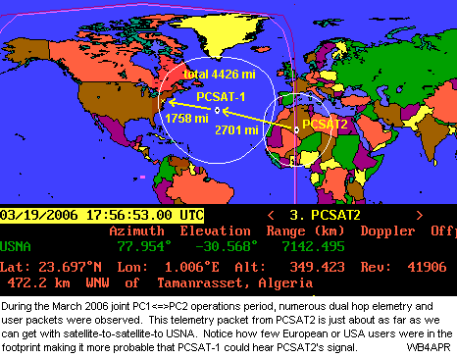
GLOBAL APRS SATELLITE CONSTELLATION: All of the Naval Academy Satellites operated on the 145.825 packet radio satellite channel. This channel was pioneered by the DOVE satellite back in the Early 90’s and has had a number of packet satellites since. As shown in figure 13, with all satellites operating on the same frequency (just like the terrestrial APRS system with all digipeaters operating generically on the same channel) the sum of all such satellites provide a continuum of support to mobile satellite operators.
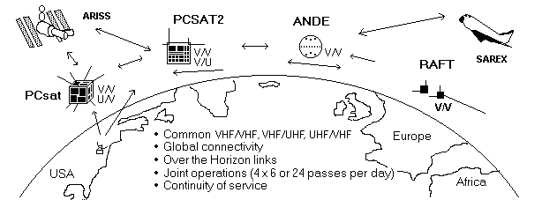

All of the spacecraft operating on 145.825 provide a generic packet relay system and a continuation of coverage and availability. Not only does this provide better access, but it also permits dual hop contacts as shown on the right. A packet from PCSAT-2 relayed by PCSAT-1 to our ground station in Maryland over a path of 4426 miles.

Most digital satellites and most of the Cubesats could support this APRS relay capability in their communications system designs. Even while performing their primary and scientific missions, these satellites could also relay occasional packets from users in view. With only 1 second per user, the power load on the satellite in this mode is miniscule. Even a cubesat power budget could handle a few additional 1 second packets per minute.

SATELLITE ALERTS: Not only are there several APRS satellite digipeaters in space, but there are numerous satellites that you can operate FM voice too while mobile with your FM rig [6]. The problem is that most of us are simply not aware of the dozen or so passes per day when we could be operating the satellites if we just knew they were in view. It turns out, your APRS radio or HAMhud display can instantly alert you and everyone else in your region any time an FM or APRS satellite comes into view. All it requires is someone in the area to set up a satellite-object server.

The satellite will appear like any other APRS object on the front panel of your radio showing you not only the callsign, name, location, distance and direction from you, but also it will show the frequency and even the current Doppler as shown below. In other words, everything you need to know on the front panel of your APRS radio. In addition, once every 10 minutes a satellite schedule is transmitted to your mobile for capture in the DX list to inform you of any satellites that may come into view in the next 80 minutes.

Over the years, dozens of AMSAT satellites could be worked from the mobile FM rig including SAREX, ARISS, SUNSAT, ECHO, UO-22, UO-23, PCSAT1, PCSAT2, SO-41, SO-50, ANDE, RAFT and GO-32. Unfortunately, at this writing, only ECHO, and sometimes ARISS and PCSAT-1 can be used reliably for packet and AO-50, and AO-51 (ECHO) for voice.

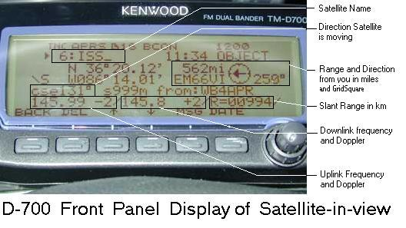
This figure of the D700 display shows the info distributed on the APRS channel locally when a satellite is in view. In this case it is the ISS. This info is updated once a minute if someone is running an APFRS satellite server in the area. The bearing and distance are shown and also the uplink and downlink frequencies plus range and Doppler.

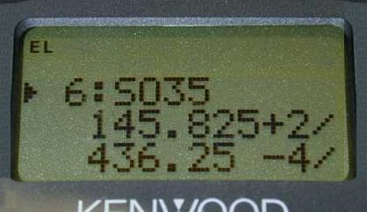
Satellite Server: Satellite Alerts are only visible if someone in your region is running an APRS data resource server such as the old DOS APRSdata.EXE, or the UIview add-on called InfoKiosk, or the software called DIGI_NED. These programs run automomously at someone’s shack keeping track of all the Amateur Satellites of use to mobiles in an area. If anyone of them comes above the horizon in that area, the software begins generating 1 minute updates to an APRS object and transmitting this object out on the APRS channel to all stations. These objects will appear on the front panel of everyone’s APRS radio or HamHUD display. On the D7 walkie-talkie display, the information is easier to see at a glance as shown in the following figures.

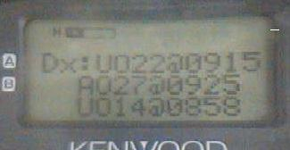
In-view Satellite data on the D7 screen shows the satellite name and operating frequencies and present Doppler. Other displays on the D7 show the direction and distance.

A special satellite schedule packet is transmitted every 10 minutes to update this display in the D7’s and D700’s DX list. It can show up to four of the upcoming satellite passes expected in the local area. This one showed the times of the next UO22, AO27 and UO14 satellites.

Terrestrial Use between passes… A National Calling Channel and Voice Alert: Although an APRS channel is wall-to-wall with packets, probably 99% of them have been relayed by a digipeater. All of these repeated packets do not have any CTCSS tone with them so the speaker can be muted by simply setting CTCSS 100 tone squelch. But, to distinguish LOCAL simplex range packets from digipeated packets, the original senders of APRS data can include a 100 Hz CTCSS tone. This is so that simple monitoring of the channel with the speaker muted by CTCSS 100 will allow for practically silent operation while still providing an audio alert if another operator is nearby and comes within simplex range. This is a very powerful APRS mobile feature called Voice Alert. Using CTCSS 100 anyone can contact such an APRS operator by voice by simply making the call on the APRS channel with tone 100 if needed [7]

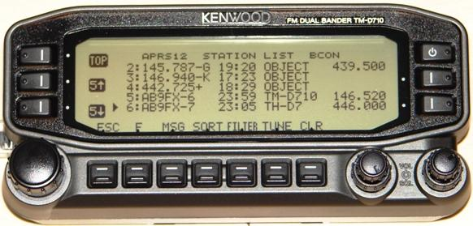
Operating Frequency Identification: The most significant new initiative in terrestrial APRS is the addition of the frequency field to the packet data. This allows APRS operators to show the voice frequency they are monitoring with their dual band radio. Adding this frequency field in everyone’s position packets that show up on the front panel of APRS radios or heads-up displays (HAMHUD) adds a new dimension in communication capability. The D710 display list (below) was sorted by callsign and stations AB9FX were reporting their monitoring frequencies. Clicking on any of these stations will reveal 3 more pages of info on that station, or you can just press TUNE button and the D710 will instantly tune to that channel and tone.

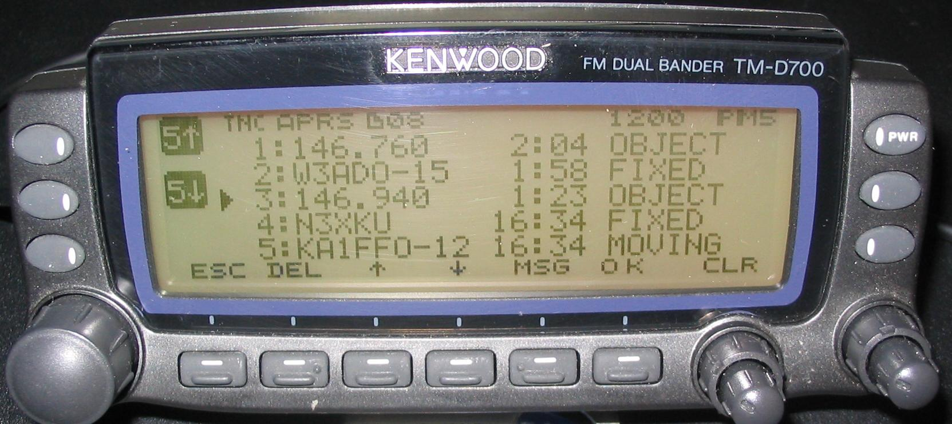
Recommended Voice Frequencies Everywhere: But there are lots of other frequency objects on APRS. To assist the mobile satellite operator and traveler, the APRS network now transmits locally recommended voice repeater frequencies in each local area [8]. You can see three of these in the figure above. These local repeater objects show the Frequency right on the front panel list and when selected, even include the Tone, Net times, and meeting dates as well. When you see one of these, you can just push the D710 TUNE or FTM-350 QSY button to tune directly to them. An additional feature is the new List SORT button which can SORT the list alphabetically or by range making it easy to find others. The display above is after an alphabetic sort so that all the Frequency objects show up at the top of the list.

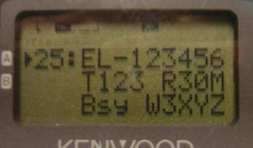
By using the recommended local voice repeater frequency as an APRS object name, these recommendations show up for the mobile traveler whenever he enters a new area. The D700 above shows the most recently received 146.76 is in direct range. The older 146.94 has moved down the list since it was heard 35 minutes earlier.

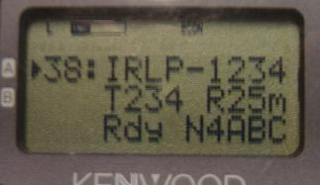
Echolink and IRLP Node Frequency Objects: Other frequencies of immediate local interest to the mobile traveler are the EchoLink nodes, IRLP nodes and Winlink Telpac stations. Echolink and IRLP nodes are displayed on the APRS radio’s list as node numbers instead of callsigns to facilitate ease of use by mobiles as shown in figure 6 and include their Frequency, Tone, Range and Status (Rdy, Bsy, Lnk). This will be useful when APRS and Echolink and IRLP are merged into the automatic Voice Relay System AVRS [9]. Two example screens of these objects are shown below.

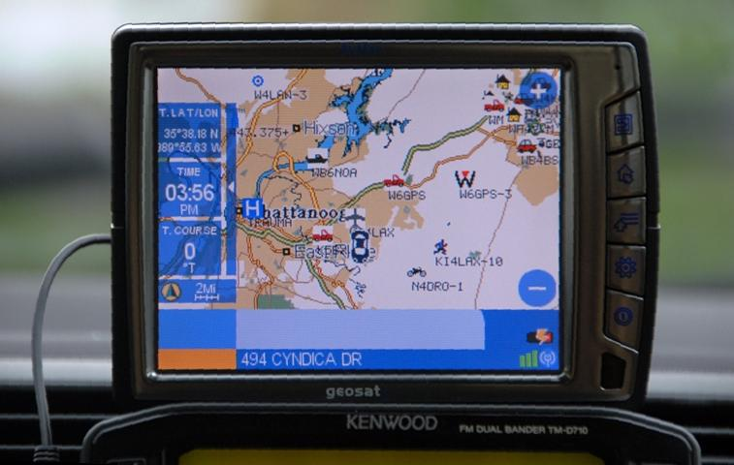
GPS Map Displays:

Not only do the APRS radios and Head’s Up displays give you textual information, any attached GPS with a map display can also display the surrounding APRS symbols of all the other APRS stations and objects in the area! The GPS map will show all surrounding APRS stations, mobiles, weather stations, and objects, right there on the GPS even those you receive via satellite. With a good GPS with built-in maps, no laptop is needed in most APRS mobiles. Recently, the AVMAP G5 even includes the full APRS symbol set so these other stations appear on the GPS map with full color symbols as shown to the right. The smaller Garmin NUVI-350 can also display multiple APRS symbols via a special interface dongle made by Argent Data Sysems (though the NUVI-350 is no longer in production).
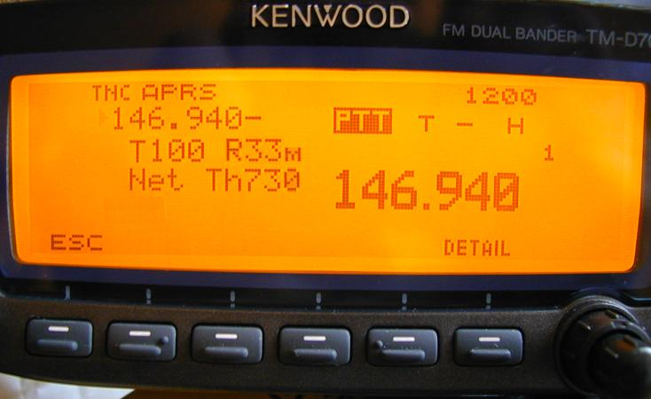
Flash-up Instant Information Display

While monitoring the satellite downlink or national APRS terrestrial channel, each new incoming packet with new information flashes on the radio or HamHud screen for 10 seconds or so as shown in the following figure. In this way you are instantly alerted to anything new in range without your hands ever leaving the steering wheel. This display is useful for conveying to travelers the location and frequency/tone of the local calling frequency as well as all other assets or satellites in view. A new feature of the D710 is that the Display Head can be used as a stand-alone APRS display when hooked to the audio connections of any radio. This is useful when removed from the mobile and maybe carried inside to the club or EOC and operated with any HT.

This D700 display shows how the left side of the radio flashes each new packet momentarily. It shows why we like to concentrate information into the first 20 or 28 bytes of a packet so that it displays well on the 10x10 display of the D7 and the 10x10x8 display of the D700 shown here. Here we see the local repeater, its tone, its typical range, and its weekly net times all in one packet.

CONCLUSION: Many of us only have time to really enjoy ham radio while we are mobile. The purpose of this article is to make sure everyone is aware of the vast potential for mobile satellite operation if we just know when a satellite is in view. This information as well as a wealth of other information should be made available to the mobile operator on his front panel screen. Due to limited space, only a few of the dozens of display screens and data formats could be shown in this article. Think of these APRS mobile displays as Tiny Web Pages of Local Live information [10] everywhere you go. Compared to cell phones, the big advantage of ham radio is it’s one-to-many access to information. But just like a dead-band, there is only information to receive if someone else is transmitting it.

So think outside the box. APRS has been available as this local information resource for over 15 years, but many operators are still not taking advantage of this valuable local and global resource. Think about what info you can put out in your own immediate simplex range neighborhood that would be useful to the traveler or visitor. But be considerate. One area’s local information, if received somewhere else, is SPAM! For everything about APRS, see http://aprs.org [11].

References:
[1] Universal Ham Radio Text Messaging – http://aprs.org/aprs-messaging.html
[2] PCSAT-1 live downlink page: http://pcsat.aprs.org
[3] Parkinsonsat web page: http://aprs.org/psat.html
[4] D700 setup: http://aprs.org/txt/D700-faq.txt
[5] APRS Emergency Tests: http://aprs.org/sset.html
[6] APRS Satellites: http://aprs.org/astars.html
[7] Voice Alert : http://aprs.org/VoiceAlert3.html
[8] Local Repeater info: http://aprs.org/localinfo.html
[9] Echolink / IRLP / APRS: http://aprs.org/avrs.html
[10] APRS Tiny Web Pages, 19th ARRL/TAPR DCC Proceedings, September 2000, Orlando Florida. Pp13-20.
[11] Main APRS web page http://aprs.org

